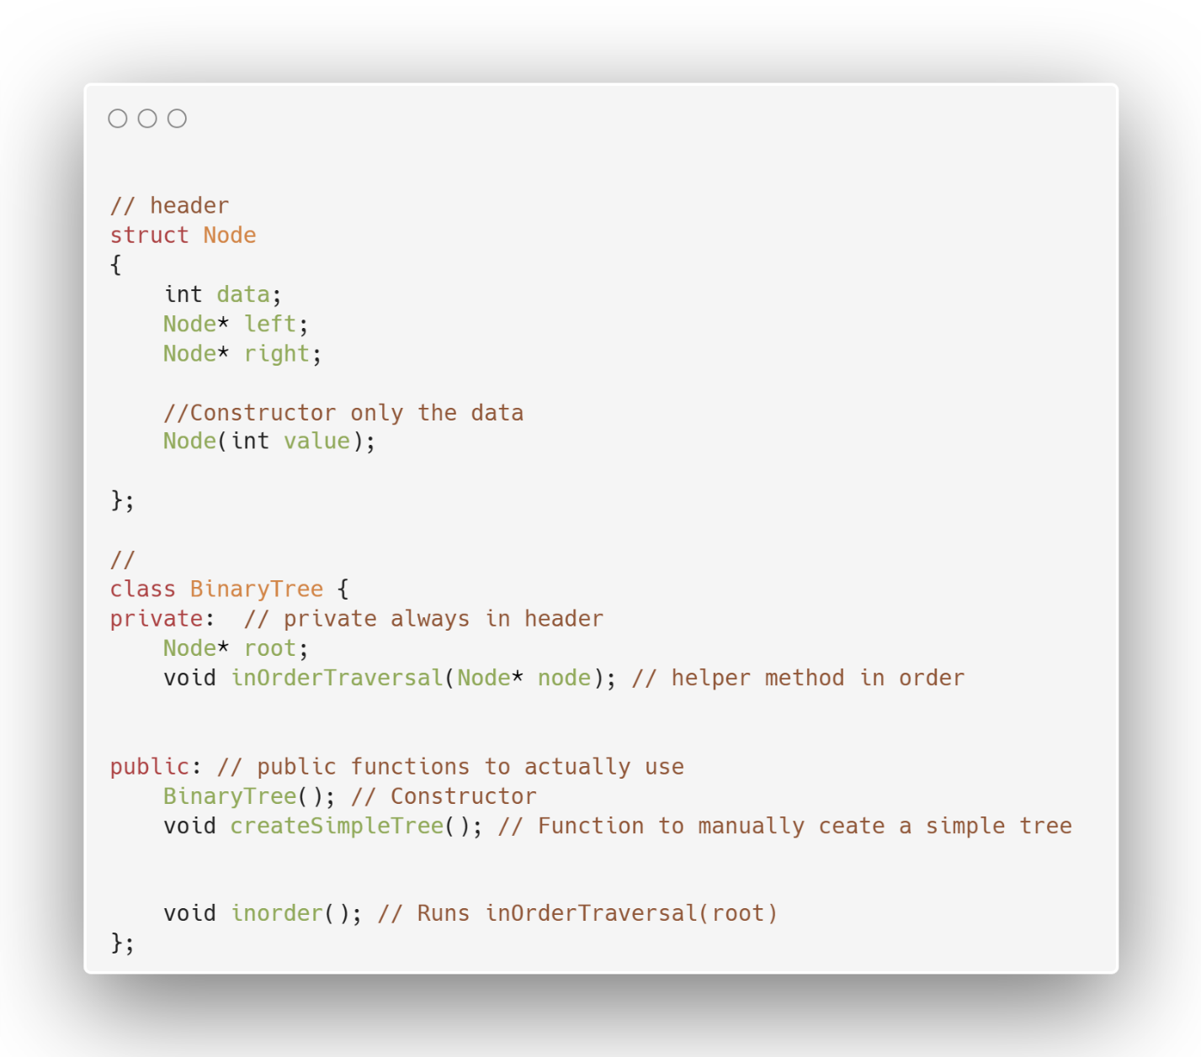

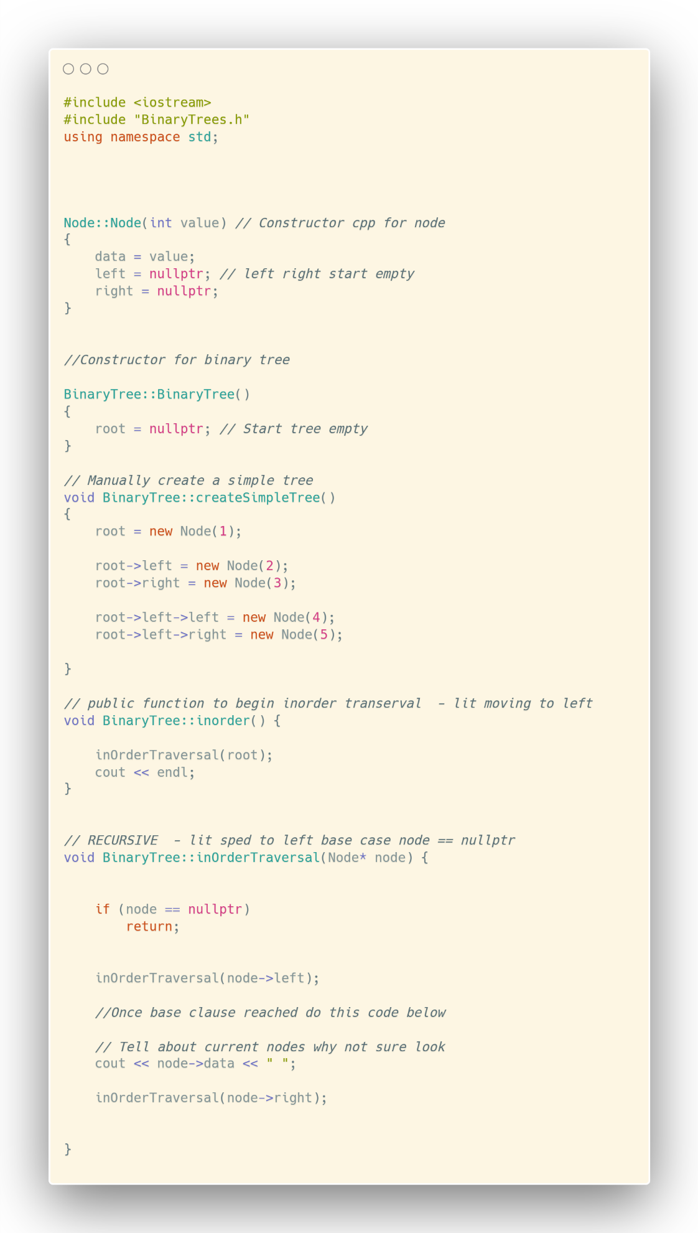
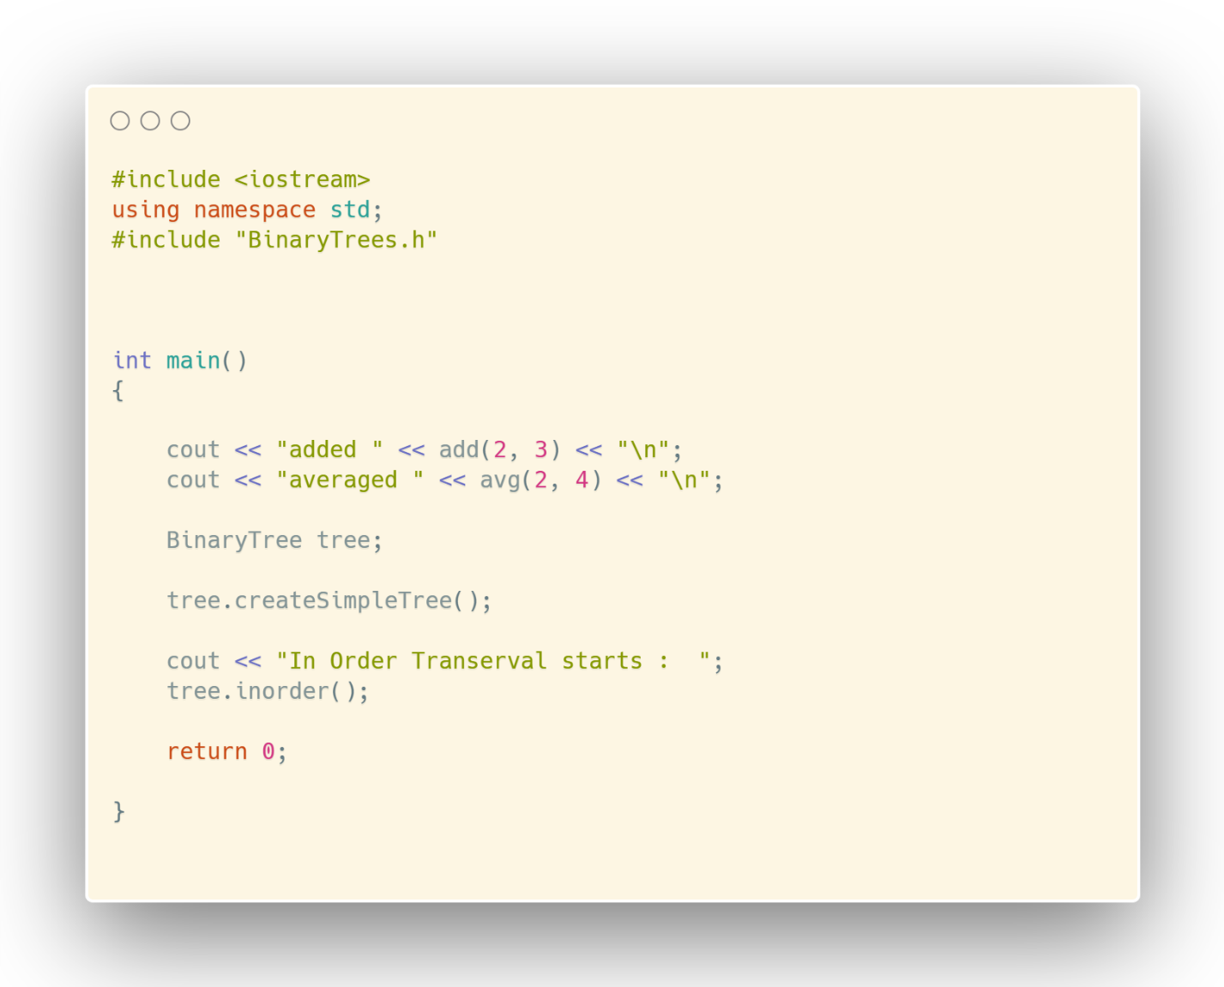

### Inorder rule (always the same):
LEFT -> LEFT - LEFT -BASE CLAUSE CLIMB UP THEN
LEFT → NODE → RIGHT EACH STEP UP

